Patient Participation Group Report
2014
This report summarises the development and outcomes of the Al-Shafa Medical Centre Patient Reference Group (PRG) in 2013/14. This report has been published on the practice website http://www.al-shafamedicalcentre.co.uk
It contains:
- Profile of the practice population and PRG
- The process used to recruit to our PRG
- The priorities for the survey and how they were agreed
- The method and results of the Patient Survey
- The action plan that was agreed and how it was agreed
- Confirmation of our opening times
- Details of Extended Hours access

Profile of the Practice Population and PRG
The practice population of Al-Shafa Centre comprises of 7621 permanently registered patients (as of March 2014). This number can be broken down into 4270 male patients and 3351 female patients. The age / Sex bands of the patient population are as follows:

Age | Male | Female
0-9 years | 653 | 704
10-19 years | 689 | 642
20-29 years | 796 | 560
30-39 | 758 | 510
40-49 | 581 | 332
50-59 | 277 | 224
60-69 | 211 | 165
70-79 | 233 | 140
80-89 | 66 | 64
90-99 | 6 | 10
100+ | 0 | 0

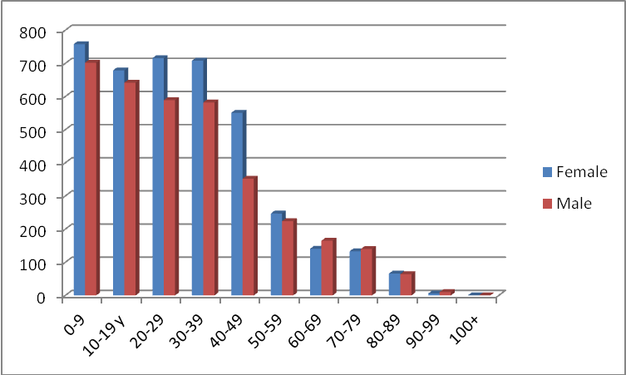

The ethnicity of the practice population is given as predominantly Pakistani (3958) with other ethnicities recorded as follows:
Ethnicity | Number of patients
Pakistani | 3897
Bangladeshi | 3561
Black | 108
White | 49
Irish | 6
Chinese | 0

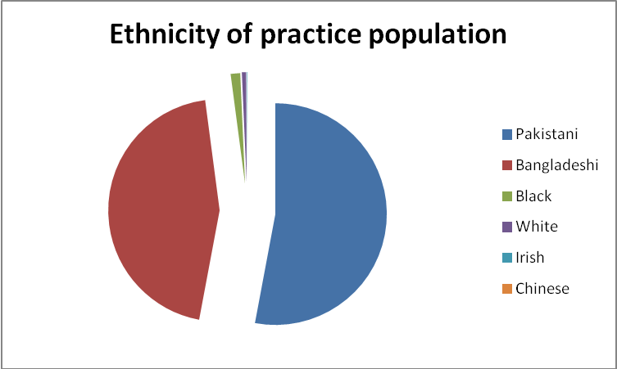
The practice population remains fairly constant at Al-shafa with relatively low levels of temporary residents.
PRG Profile
In late winter 2006 the practice began recruiting patients to the Patient Reference Group. As of March 2013 the PRG comprising of 6 members. Their age range from 19 to 65 years, the PGR group consists of a Zafar Ali vice chair (Denise Woods), PRG members Sonia Benjamin, Sobia Kauser, Rabia Bibi. The group has gone 5 to 6 members, and now the practice has the presence of female representatives which has been difficult to achieve for the past years.
The Process used to recruit to our PRG
We continued promoting our PRG throughout the year and are aware that the demographics of the group need to be representative of the practice population. As are a practice delivering to patients in the inner city area it is always challenging to recruit patients and hence have kept PRG membership open to all.
The priorities for the survey and how they were agreed
We continue to have a lively, enthusiastic PRG who meet on a bi-monthly basis, along with two practice staff representatives. The group were very keen to identify priorities for a patient survey this year. The main areas of priority were awareness of the ‘accesses, feedback on a proposed ‘proposed walk-in clinics in the morning and evening appointment’ clinic and satisfaction with practice staff.
The method and results of the Patient Survey
Once the areas of priority had been established, it was decided that we have an independent body to analyse, we appointed IPQ to send the paper survey was carried out these were returned to IPQ to analyse.
The action plan that was agreed and how it was agreed
PRG also decided we take slow steps and do action things which matter to patients and then slowly work around other areas in the survey. From these discussions an action plan was devised (copy attached). The main actions were:
Action | Plan | Date of implementation
Access | - Practice to address regular attendees to the practice as this limits appointment to other non-regular attendees. | Therefore no changes will be implemented
Telephone Consultation | Frequent Attendees to the practice will be given a simple form to put their details and request for their choice of Dr  Once the form is received by the Dr they will get back to patients on the same day to provide telephone consultation.  A box will be allocated in the reception area to provide the completed forms.  Telephone consultation leaflet to be displayed in the patient waiting area/ reception | 21.03.2014
Satisfaction with Practice Opening hours | The patients who completed the questionnaire seemed very satisfied with the opening hours of the surgery with most commenting positively. PRG was also happy with the practice opening hours | No action required
Text Messaging Services | Mobile phone test messaging service to be started to send patient text messages i.e. reminder of appointments etc. | 25.06.2014

Confirmation of Our Opening Hours
Confirmation of our opening hours and the method of obtaining access to services throughout the core hours are as follows:

Reception times Surgery times
Monday: 08:00 - 19:00 09:00 – 13:30, 16:30 – 18:30
Tuesday: 08:00 - 19:00 09:00 – 13:30, 16:30 – 18:30
Wednesday: 08:00 - 19:00 09:00 – 13:30, 16:30 – 18:30
Thursday: 08:00 - 19:00 09:00 – 13:30, 16:30 – 18:30
Friday: 08:00 - 19:00 09:00 – 13:30, 16:30 – 18:30
Saturday: Closed Closed
Sunday: Closed Closed
Address/Telephone
Al-Shafa Medical Centre
5-7 Little Oaks Road
Aston
Birmingham
B6 6J
Phone: 0121 328 1984
Fax: 0121 327 3755
Appointment Telephone No.: 0121 328 1977

